Anmol Shrestha

CSE 3311-002

03/08/2022

Static Code Analysis

I am in team-4 and our project is a paint inventory management system. We are making a website for this project and for the static code analysis I used SonarQube. I had recently used SonarQube in software testing and maintenance class, so I was familiar with the tool.

A. Here are the steps I followed for the static code analysis tool SonarQube on our “Picasso” project.

1. I opened the command prompt on administration mode.

2. I ran the following commands in order:

a. Docker pull sonarqube:latest

b. Docker images

c. Docker ps

d. Docker container run –d –-name sonarqube –p 9000:9000 sonarqube:latest

3. Then, I opened localhost:9000 in the web browser

4. I clicked on create new project and then choose manually.

5. I have the project name and a project key was generated.

6. I then, clicked locally and generated a token and choose to continue.

7. I clicked on other and then windows and downloaded the SonarQube zip file and extracted it.

8. I went to my computer’s environment variable and added the bin folder in the SonarQube file

to the path.

9. Lastly, I ran the following command:

sonar-scanner.bat -D"sonar.projectKey=asdsdss" -D"sonar.sources=." D"sonar.host.url=http://localhost:9000" -D"sonar.login=9ef13d5de69bf5152fcc0c334c748add02a472e0"

10. I got the results in localhost:9000 in the browser.

B. The four warnings are as follows:

1. 'user' is already declared in the upper scope. (Correctness)

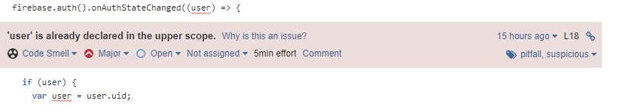

B.1) Yes, any code execution can reach line L. For example, with the following method call:

database.ref("Picasso").child(child).on("value",getData,errData);

B.2) Yes, the behavior can occur at line L.

B.3) Yes, line L can be reached by normal execution of method M.

B.4) Yes, the behavior can occur at line L.

2. Unexpected empty arrow function. (Correctness)

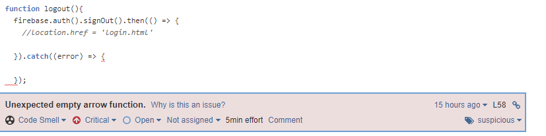

B.1) Yes, any code execution can reach line L. For example, when you click logout button and there is an error logging out.

B.2) Yes, the behavior can occur at line L.

B.3) Yes, line L can be reached by normal execution of method M.

B.4) Yes, the behavior can occur at line L.

3. Remove the declaration of the unused 'errorCode' variable. (Bad Practice)

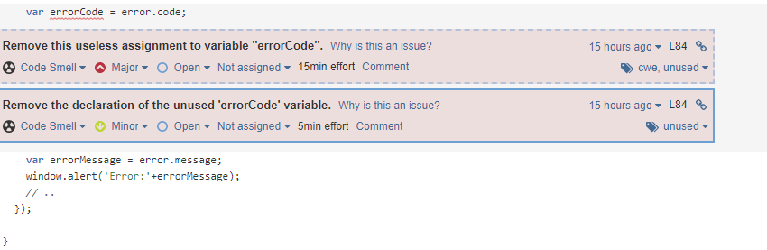

B.1) Yes, any code execution can reach line L. Since it is just a variable declaration, it will always be executed.

B.2) Yes, the behavior can occur at line L.

B.3) Yes, line L can be reached by normal execution of method M.

B.4) Yes, the behavior can occur at line L.

4. Remove this commented out code. (Bad Practice)

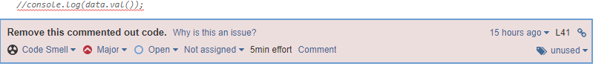

B.1) Yes, any code execution can reach line L. Since it is just a commented-out code, it never gets executed.

B.2) Yes, the behavior can occur at line L.

B.3) No, line L can be reached by normal execution of method M.

B.4) Yes, the behavior can occur at line L.